Why can’t my child wear floatation devices
at the City of Mountain Home Swimming Pool?
Give your child the best flotation device of all: Swimming skills!

Water wings, swimmies, floaties, life jackets, swimsuits with flotation devices inside them etc., are flotation devices that assist a child to stay afloat in water. These floatation devices actually hinder young swimmers from learning the proper techniques to swim effectively. For this reason, the City of Mountain Home Parks and Recreation department does not allow these devices to be used in our public swimming pool. The following is a partial list of the reasons for this policy:
- Flotation devices teach children incorrect body position for swimming- head up and legs underneath
- Flotation devices hinder arm movement necessary for swimming
- Flotation devices give both parent and child a false sense of security and encourage poor swimmers to swim into unsafe conditions such as deep water
- Flotation devices may slip off or be removed by the child where they cannot stand up, leaving the child without flotation in an area where they cannot swim
- Continued use of flotation devices by children can develop a dependency which is difficult to overcome later in life
- Flotation devices are not recommended by either the American Red Cross or the United States Coast Guard as a supplement to parental supervision in the water.

We strongly suggest that anyone unsure of the child’s swimming ability to register for swimming lessons. Swim lessons are offered here at the City of Mountain Home Public Pool as well as other Recreation Departments in the area.
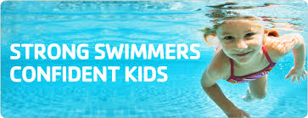
If you have questions that were not answered, please feel free to call the Parks & Recreation office at 587-2112. We hope you enjoy your swim experience at the Mountain Home City Pool!

